**Mini Report for Part 2**

**Topic Description:**

The purpose of this data set is to predict poker hands. Given the sequence of 5 'community' cards, drawn from a standard deck of cards, what hand is most likely present with at least one of the players in the game.

**Data Description:**

This data was acquired from UCI's Machine Learning repository. The data comes already split into training and testing data. Each record is an example of a hand consisting of five playing cards drawn from a standard deck of 52. We were provided with 25,010 poker hands in train.csv and 1,000,000 in test.csv. Suits and ranks are represented as ordinal categories. Each card is described using two attributes (suit and rank), for a total of 10 predictive attributes. There is one Class attribute that describes the "Poker Hand". The order of cards is important, which is why there are 480 possible Royal Flush hands as compared to 4 (one for each suit - explained in more detail below.

**Attribute Information:**

1) S1 "Suit of card #1"

Ordinal (1-4) representing {Hearts, Spades, Diamonds, Clubs}

2) C1 "Rank of card #1"

Numerical (1-13) representing (Ace, 2, 3, ... , Queen, King)

3) S2 "Suit of card #2"

Ordinal (1-4) representing {Hearts, Spades, Diamonds, Clubs}

4) C2 "Rank of card #2"

Numerical (1-13) representing (Ace, 2, 3, ... , Queen, King)

5) S3 "Suit of card #3"

Ordinal (1-4) representing {Hearts, Spades, Diamonds, Clubs}

6) C3 "Rank of card #3"

Numerical (1-13) representing (Ace, 2, 3, ... , Queen, King)

7) S4 "Suit of card #4"

Ordinal (1-4) representing {Hearts, Spades, Diamonds, Clubs}

8) C4 "Rank of card #4"

Numerical (1-13) representing (Ace, 2, 3, ... , Queen, King)

9) S5 "Suit of card #5"

Ordinal (1-4) representing {Hearts, Spades, Diamonds, Clubs}

10) C5 "Rank of card 5"

Numerical (1-13) representing (Ace, 2, 3, ... , Queen, King)

11) CLASS "Poker Hand"

Ordinal (0-9)

0: Nothing in hand; not a recognized poker hand

1: One pair; one pair of equal ranks within five cards

2: Two pairs; two pairs of equal ranks within five cards

3: Three of a kind; three equal ranks within five cards

4: Straight; five cards, sequentially ranked with no gaps

5: Flush; five cards with the same suit

6: Full house; pair + different rank three of a kind

7: Four of a kind; four equal ranks within five cards

8: Straight flush; straight + flush

9: Royal flush; {Ace, King, Queen, Jack, Ten} + flush

Ranking of Cards: A K Q J 10 9 8 7 6 5 4 3 2 1

**Method**

Used Linear Regression implementation

**Results**

Estimated Y-Intercept Coefficient:

[0.62958355]

Coefficients:

[[ 0.00130416 -0.0005927 -0.00121961 -0.00048995 0.00492892 -0.00100049

0.00018961 0.0017398 -0.00521309 -0.00045191]]

Average error : 0.6223786841937504

Residual mean squared error with test data: 0.7876203494132424

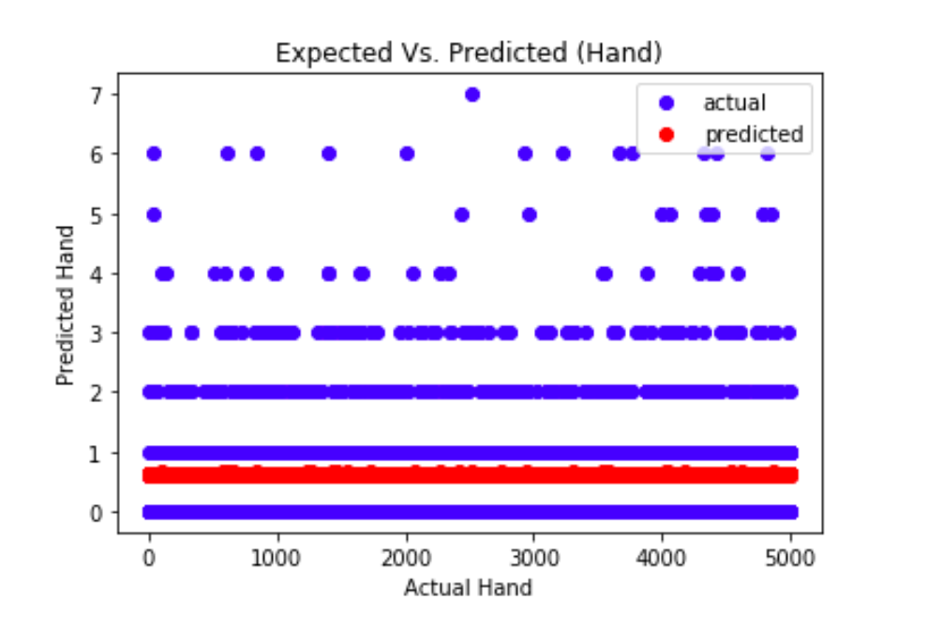

The end score of the model: 0.00022418377743316234

**Conclusion**

The end result of predicting a poker hand with the given data using linear regression implementation showed to have an accuracy of approximately 42.2498%.